软件设计复习提纲
1名词解释：
模块化、信息隐藏、软件体系结构（三个不同方面）、4+1 View、GRASP模式（或其中之一）、设计模式、MVC

模块化：模块化是指解决一个复杂问题时自顶向下逐层把系统划分成若干模块的过程。每个模块完成一个特定的子功能，所有的模块按某种方法组装起来，成为一个整体，完成整个系统所要求的功能。
- 模块是一个程序语句的集合，有一个名字，系统的其它部分可以通过这个名字调用它；易于实现和维护
- 模块化指模块可以被“独立”的对待：能单独理解每一个模块，能单独使用或复用每个模块，能单独构建每个模块，一个模块的失败不会影响其它模块
- 模块化应该注意： 任务职责单一分配而子程序分配； 对自己可见的设计决策对外部模块不可见；实现上支持灵活性；不代表处理步骤；高内聚低耦合。

信息隐藏：一种设计原则。每一个模块都隐藏一个重要的设计决策，只有模块的组成部分才知道细节。所有的设计决策都是相互独立的。这样如果一个设计决策改变，程序的其它部分不用做扩展的修改。这种保护机制包括提供一个稳定的接口，隐藏实现即易改变的细节。（来源:维基+ppt）
信息隐藏的原则
  - 每一个模块的是实现都是一个秘密
  - 每一个模块的接口都抽象且精确的描述
  - 从可能改变的实现细节中抽象
  - 把不能隐藏的可变部分参数化

软件体系结构:（高层+关注点+决策）
理解体系结构：
- 高层结构
- 关注点
- 设计决策
部件、连接件、配置
高层抽象的作用

高层结构

需求（质量属性）、项目环境、商业目标
交流媒介的作用

关注点

问题、候选设计、理由、解决方案
指导开发的作用

设计决策

软件体系结构

图5-1 理解软件体系结构的要素

- 高层结构：
- Components are the locus of computation and state 系统的主要状态和计算
- Connectors are the locus of relations among components 部件间的关系
  - Connector deserve first-class
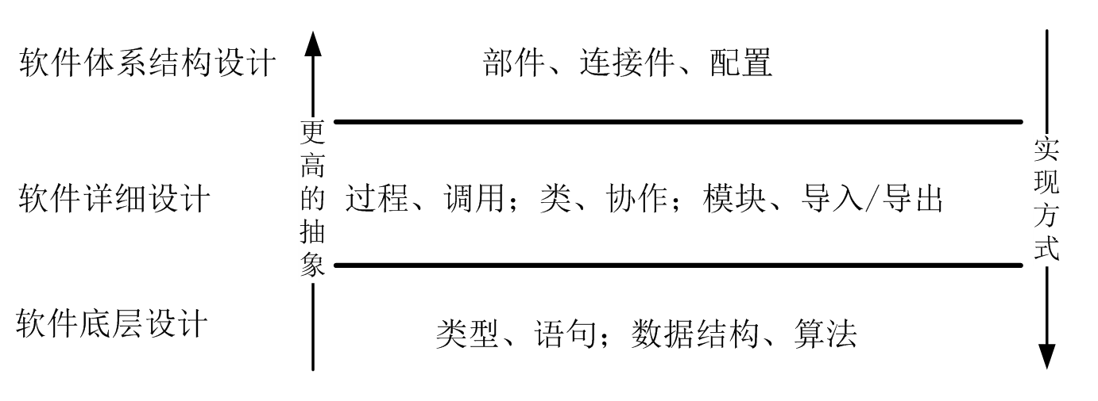
注意：部件和连接件都是第一等级实体，占同等主要地位，连接件不直接关联部件，configuration决定了部件和连接件的匹配关系。
Connector独立于component: connection的定义应该本地化；访问限制可能在connector包含了功能逻辑；connector可能很复杂；所有的结构元素彼此独立，部件，连接件独立，部件间关系可能不确定。
体系结构=设计体系结构+抽象体系结构。

部件+连接件+配置
1部件：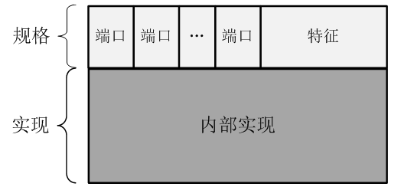
- Elements that encapsulate processing and data in a system’s architecture are referred to as software components 负责系统的主要数据和处理的元素
- Definition
  - A software component is an architectural entity that
    - encapsulates a subset of the system’s functionality and/or data
封装基本功能数据
    - restricts access to that subset via an explicitly defined interface
通过明确定义的接口限制对内部访问
    - has explicitly defined dependencies on its required execution context
明确定义了对其执行所需要context上下文的依赖
- Components typically provide application-specific services
部件通常提供了针对特定应用的服务
- Implementation实现
  - Primitive Components原始部件
  - Classes, Functions
  - Modules, Package
  - Layers
  - Files, Databases
  - Clients, Servers
  - Composite components 复合部件
  - Configuration of smaller components and connectors
2连接件： 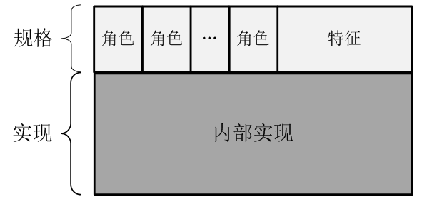
- In complex systems interaction may become more important and challenging than the functionality of the individual components 规格+实现
- Definition
  - A software connector is an architectural building block tasked with effecting and regulating interactions among components
负责封装交互信息协调component间的交互的体系结构块，交互与component无关。Interaction的封装基于角色和规则，定义了hookup的规则，而不是hookup的事物。
  - They mediate interactions but are not “things” to be “hooked up;” rather, they provide the rules for hooking-up.
- Connectors typically provide application-independent interaction facilities
提供基于应用的交互设施
- Implementation实现
  - Primitive connectors
  - Events
  - Client/server middleware
  - Messages and message buses
  - Shared variables
  - Procedure calls (local or remote)
  - Pipes
  - Adaptors
  - Composite connectors
    - Configuration of smaller components and connectors
3配置configuration：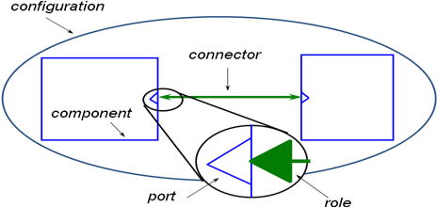
- Components and connectors are composed in a specific way in a given system’s architecture to accomplish that system’s objective描述给定系统体系结构实现系统目标的具体方式。
- Definition
    - An architectural configuration, or topology, is a set of specific associations between the components and connectors of a software system’s architecture软件体系结构的拓扑，components connector的具体关联。
- 关注点concern：
- 软件体系结构的主要关注点可以分为三个类型：
- 需求。需求是用户和维护人员关注的内容，它包括（要求系统帮助用户完成任务的）功能需求，也包括（衡量功能实现程度的）质量属性。一个好的软件体系结构必须要承载需求，以完成从需求向设计的转换与过渡。
- 项目环境。项目环境是客户、项目管理者和开发者关注的内容。客户关注的是项目的商业环境，例如目标市场的大小等。项目管理者关注的是项目的开发环境，例如成本、人员组成等。开发者关注的是技术环境，例如中间件平台的选择等。项目环境限制软件体系结构设计的决策范围。
- 商业目标。商业目标是客户的主要关注内容，它说明了软件系统被开发的出发点和战略目标。商业目标是引导软件体系结构设计的上下文，为软件体系结构的设计决策指明方向。
- Rational of software architecture 软件体系结构的规则，交流媒介
- Promotes shared mental model among developers and other stakeholders
开发者和其他涉众间共享精神模型
  - Janus between problem domain and solution system, ensure the traceability of requirements to designs问题查找解决方案。问题域和接系统的关系，保证需求和设计的可追溯性。
  - Shows how functional and non-functional requirements are met 功能和肺功能需求如何满足
  - Architects are agents of customs, not developers 体系架构师应当代理顾客说话而不是开发者
  - The concept integrity represented by software architecture come from requirements acquired from customs 概念完整性：由用户提出的需求
  - 共享精神模型的涉众&特征（功能性，体系结构和质量属性）：
- Functionality and quality attributes are orthogonal.功能和质量属性是基础
- Achieving quality attributes must be considered throughout design, implementation, and deployment.质量属性必须在设计，实现和部署中都考虑
- Satisfactory results depend on getting the big picture (architecture) & the details (implementation) right. 满意的结果取决于体系机构（bigpicutre）和实现（detail）的正确性
- 质量属性分类：
    - Qualities of the system系统本身质量：
      - availability, modifiability, performance, security, testability, and usability.可靠性，可修改性，性能，安全，可测试性，可用性
    - Business qualities业务质量
      - time to market, cost & benefit, projected life, target market, rollout schedule, legacy integration.面试时间，成本，收益，生命周期，目标市场，遗留系统，规划
    - Architectural qualities 体系机构质量
      - conceptual integrity, correctness & completeness, buildability 概念完整性，正确性&完整性，可构建性
- 设计决策：Design Decision
  - A software system’s architecture is the set of principal design decisions about the system 软件体系结构是系统的最基本决策的集合。
  - Principal” implies a degree of importance that grants a design decision “architectural status”“最基本”：设计决策在保证体系结构状态上的重要性
      - It implies that not all design decisions are architectural
      - That is, they do not necessarily impact a system’s architecture
  - Reflects major design decisions反映主要的设计决策 关注点
    - Architecture establishes the context for design and implementation 为设计和实现提供了上下文
    - Rationale for why one approach taken, what impact it has 选择的理由和可能的影响
  - an architectural design decision as:
体系结构中做一次的增删改为decision，理由，规格，对后续开发的限制，对系统设计产生的额外影响。
    - A description of the set of architectural additions, subtractions and modifications to the software architecture, the rationale, and the design rules, design constraints and additional requirements that (partially) realize one or more requirements on a given architecture.
其余概念：
- Rationale: The reasons behind an architectural design decision决策的原因
  - It describes why a change is made to the software architecture.
- Design rules and design constraints: Prescriptions for further design decisions. 后续设计决策的前提。规则和限制。对湘西设计的限制要求（什么事能做）
  - Rules are mandatory guidelines,
  - whereas constraints limit the design to remain sound.
- Design constraints: 限制
  - describe the opposite side of design rules. They describe what is not allowed in the future of the design.非强制性规定，（什么事不能做）
- Additional requirements额外需求额外设计决策
  - A design decision may result in additional requirements to be satisfied by the architecture.
  - These new requirements need to be addressed by additional design decisions.

补充：定义：
- Perry and Wolf
  - Software Architecture = { Elements, Form, Rationale }
What基本单位 how形式 why 限制
    - Element: Process+Data+Connection
  - “The architecture of a software system defines that system in terms of computational components and interactions among those components." [Shaw and Garlan 96]软件体系结构定义了系统的计算部件和部件间的交互
    - Component+connector+configuration
部件+连接件+配置
  - “The software architecture of a program or computing system is the structure or structures of the system, which comprise software components, the externally visible properties of those components, and the relationships among them.” [Bass, Clements, and Kazman 98]软件体系结构是系统的结构，包括了软件部件，部件对外可见的属性和部件间的关系
部件+对外可见属性+部件间关系
Every software has one or more architecture structures 所有软件有一个或者多个体系结构
理解：参考去年整理：
软件体系结构的概念
- 高层架构，
包括静态和动态属性：
  - 指该系统的结构，包括软件组件，及其外部可见属性，以及组件间的关系；由计算组件和组件间交互组成；
  - 组件：
  - 是一个构造块，通过接口描述其服务的计算或数据仓库的集合。常见组件：类，函数，模块，包，层，文件，数据库，客户端，服务器
  - 组件是逻辑元素，粒度可自由控制，而对象是实现元素，粒度较小，且两者抽象程度不同。
  - 如何定义组件：
  - 组件的函数和职责，以及接口必须被定义
  - 核心设计类需要被定义：核心类实现组件主要功能，实现接口，但是只有类的Skeleton被提供定义，具体内容需要设计阶段给出
  - 连接器：
    - 允许组件间交互的构造块（不是简单的接口），降低组件间的耦合，同时连接互相不兼容的组件
    - 连接器包括显式的和隐式的，有时仅仅是一个通道，有时包括自己的逻辑和复杂度
    - 常见连接器：
    - （Implicit）事件，C/S中间件，消息和消息总线，共享变量，过程调用（本地、远程），管道，
    - （Explicit）代理，适配器
- 交流：
在开发者和其他涉众间提供一个共享的精神模型，同时面向问题域和解空间，保证需求可以追踪到实现
    - 是客户的代理，由客户的需求提炼而来，不同的涉众关注系统的不同方面，软件架构使得对于一个大且复杂系统的不同关注可以被表达、协商达成一致，从而便于管理
    - 表现功能和非功能需求（质量）如何被满足
    - 质量的种类：
    - 系统质量：availability, modifiability, performance, security, testability, usability.
    - 商业质量：投放市场的时间，投入&回报，计划周期，目标市场，首次展出计划，遗留系统整合
    - 建筑质量：观念一致性，正确性&完整性，可建造性
- 设计决策：
反映设计决策
- 往往根据架构师的知识背景实现
- 建立了软件设计和实现的背景，解释一种方法被采用的根本原因，它有什么影响
- 结构决策是最基本的决策，改变它将会引起很多连锁的反应
- 架构定义了实现的约束（组件分解，外部可见特性和接口），限定了一个系统的质量属性，决定了开发人员的结构组成，对于系统资源分配的决策约束了实现
- 使得修改变得容易控制，方便于系统原型的演化
- 软件架构是系统的基本组织，包含了它的组件，及其关系与环境，以及控制设计和演化的原则

4+1 View:多视图模型
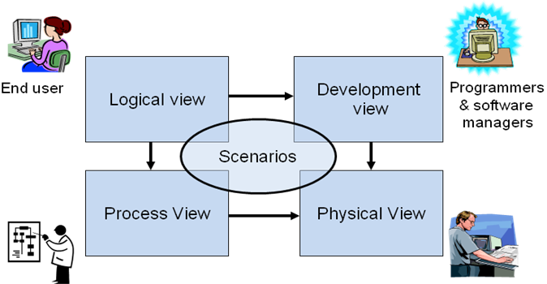
- Logical View 最主要，出发点，需求的映射
(Object-oriented Decomposition)
- The system is decomposed into a set of key abstractions, taken (mostly) from the problem domain, in the form of objects or object classes 系统被分解为关键抽象，从问题域而来，以对象或者对象类的形式存在
  - {Component, connector, configuration} better
Viewer: End-user 最终用户
considers: Functional requirements- What the system should provide in terms of services to its users.功能需求，提供给用户的服务，功能性分析，设计决策
- This decomposition is not only for the sake of functional analysis, but also serves to identify common mechanisms and design elements across the various parts of the system
- Process View
(The process decomposition)
viewer: Integrators 集成师
considers: Non - functional requirements (concurrency, performance, scalability)
非功能需求，系统运行后的特性：并发，性能，吞吐
style: Several styles would fit in this view (Garlan and Shaw ‘s Architecture styles) 多种
- Uses multiple levels of abstractions, a logical network of processes at the highest level 多层次抽象性，最高层是进城的逻辑网络
- A process is a grouping of tasks that form an executable unit:
相关tasks集结成可执行单元，单独进程
- The software is partitioned into a set of independent tasks 独立
  - Major Tasks: Arch. relevant tasks 主：体系结构相关
  - Minor Tasks: Helper tasks. (Buffering) 辅：辅助次要
- Development View
(Subsystem decomposition)
Basis of a line of product
- The development architecture of the system is represented by module and subsystem diagrams, showing the ‘export’ and ‘import’ relationships. 系统分解，产品线基础，模块，子系统，import,export
Viewer: Programmers and Software Managers开发人员，软件管理人员
considers: software module organization 软件模块组织：层次结构，管理，复用，工具限制
(Hierarchy of layers, software management, reuse, constraints of tools)
Style: layered style 分层 （优点）
层层之间明确接口，并行开发程度高
最底层可供复用
每层可以在分解为模块
- Physical View
(Mapping the software to the Hardware)
- Topology, Communication)
  - The various elements identified— networks, processes, tasks, and objects—need to be mapped onto the various nodes.
    - We expect that several different physical configurations will be used
Viewer: System Engineers 系统工程师
Considers: Non-functional req. regarding to underlying hardware (availability, reliability (fault-tolerance), performance (throughput), and scalability) 物理拓扑和交互，非功能需求映射到硬件方面：可用性，可靠，容错，性能，吞吐，可拓展性
- Scenarios
(Putting it all together)
- The elements in the four views are shown to work together seamlessly by the use of a small set of important scenarios 指挥，连接四个试图
Viewer: All users of other views and Evaluators.试图使用者和评估者
Considers: System consistency, validity试图间一致性，可验证性
- Help Architect during the architecture design 设计依据
- Help illustrate and validate the document 说明和验证文档

GRASP模式:
GRASP:
- GRASP stands for General Responsibility Assignment Software Patterns
- These are not ‘design patterns’, rather fundamental principles of object design
- GRASP patterns focus on one of the most important aspects of object design, assigning responsibilities to classes.
- GRASP patterns do not address architectural design
- 9种：
- Expert:
Assign a responsibility to the class that has the information necessary to fulfil the responsibility.
Related to another fundamental responsibility assignment strategy central to object-oriented design:
  - “Do It Myself.” (Coad)
  - A Book calculates its own due date.
Closely related to and also known as:
  - “Put services with attributes.” (Coad)
  - “That which knows, does it.” (Seive)
Maintain encapsulation of information ;Promotes low coupling ;Promotes highly cohesive classes;Can cause a class to become excessively complex

- Creator:
Determine which class should create instances of a class based on the relationship between potential creator classes and the class to be instantiated:
By creator, assign class B responsibility of creating instance of class A if
B aggregates A objects B contains A objects
B records instances of A objects B closely uses A objects
B has the initializing data for creating A objects
where there is a choice, prefer B aggregates or contains A objects
Promotes low coupling by making instances of a class responsible for creating objects they need to reference
By creating the objects themselves, they avoid being dependent on another class to create the object for them
- Low Coupling:
Problem: To support low dependency and increased reuse?
Solution: Assign responsibilities so that coupling remains low.
- High Cohesion:
Problem:To keep complexity manageable?SOLUTION: Assign responsibilities so that cohesion remains high.
Very Low Cohesion: A Class is solely responsible for many things in very different functional areas
Low Cohesion: A class has sole responsibility for a complex task in one functional area.
High Cohesion. A class has moderate responsibilities in one functional area and collaborates with classes to fulfil tasks.
High cohesion: Classes are easier to maintain ;Easier to understand;Often support low coupling ;Supports reuse because of fine grained responsibility

- Controller:
Problem: To assign responsibility for handling a system event?
Solution: If a program receive events from external sources other than its graphical interface, add an event class to decouple the event source(s) from the objects that actually handle the events.
- Using a controller object keeps external event sources and internal event handlers independent of each other’ type and behaviour
- The controller objects can become highly coupled and uncohesive with more responsiblities
- Polymorphism:
Problem:To handle alternatives based on types?
Solution: When alternate behaviours are selected based on the type of an object, use polymorphic method call to select the behaviour, rather than using if statement to test the type.

- Pure Fabrication:
Problem: To not violate High Cohesion and Low Coupling?
Solution: Assign a highly cohesive set of responsibilities to an artificial class that does not represent anything in the problem domain, in order to support high cohesion, low coupling, and reuse. 指的是，要实现高内聚，必须将功能单一化，虽然有时候class满足专家模式，但是，对于一些大型的，需要多次重用的方法，需要单独提取出来作为一个类，这样能够增加重用性。

- Indirection:
有时候需要用间接的耦合来代替直接的耦合，对于上一个例子，通过建立一个中间类别来解开sale和database之间的耦合，把直接耦合转化为间接耦合。

- Protected Variations:
Problem:How to design objects, subsystems, and systems so that the variations or instability in these elements does not have an undesirable impact on other elements?
Solution:Identify points of predicted variation or instability; assign responsibilities to create a stable interface around them.

设计模式:
- A design pattern设计模式
  - abstracts a recurring design structure
设计结构的抽象，针对疑难点，对原则思想的应用
  - comprises class and/or object 组成：类和对象及其之间的关系
dependencies, structures, interactions, conventions
  - distills design experience设计过程中的经验总结
- Design patterns have 4 essential elements:
  - 名称Pattern name: increases vocabulary of designers
  - 问题Problem: intent, context, when to apply
  - 解决方案Solution: UML-like structure, abstract code
  - 结果Consequences: results and tradeoffs
Program to interface: All derived classes must be substituteable for their base class(LSP)
Iterator: Provide a way to access the elements of an aggregate object sequentially without exposing its underlying representation.
Proxy: Provide a surrogate or placeholder for another object to control access to it
Prototype: Specify the kinds of objects to create using a prototypical instance, and create new objects by copying this prototype
De-Coupling Methods: 1 Avoiding Repetition: Do it Once
2 DIP : Abstractions should not depend on details. Details should depend on abstractions
3Indirection：Proxy
4Collaboration Design: Mediator:
Defines an interface for communicating with Colleague objects ;Typically mediator is informed of some event or situation
5Bridge :
- The normal method of dealing with an abstraction having several implementations is through inheritance.
- However, this permanently binds the implementation to the abstraction.
- This is not always flexible enough. You may want to modify or extend the abstraction or implementations independently.
The Facade Design Pattern: Problems
- Provides a unified interface to a set of interfaces in a module/subsystem
- Defines a higher-level interface that makes the module/subsystem easier to use
  - Hiding the internal implementations
Strategy pattern
Pulling an algorithm out from the object that contains it, and encapsulating the algorithm (the "strategy") as an object ;Establishing an inheritance structure for algorithms
State pattern: object's behavior depends upon its state; operations have large multipart selection structures - different options for each state
Decorator pattern: Decorators expand the functionality of an instance of a class without changing the class code
Adapter: Convert the interface of a class into another interface clients expect. ;Lets classes work together that couldn’t otherwise because of incompatible interfaces

MVC:
思想:从表示和控制逻辑中分离出核心商业模型功能，允许共享企业数据模型，使支持多客户更易实现、测试和维护。
- 模型：用于封装与应用程序的业务逻辑相关的数据以及对数据的处理方法
- 视图：负责生成用户界面的部分
- 控制器：控制器起到不同层面间的组织作用，用于控制应用程序的流程
2模块化
- 结构化的内聚与耦合类型；
参考笔记
耦合：
( can not stand )内容耦合：如果发生下列情形，两个模块之间就发生了内容耦合
一个模块直接访问另一个模块的内部数据;
一个模块不通过正常入口转到另一模块内部;
两个模块有一部分程序代码重迭(只可能出现在汇编语言中);
一个模块有多个入口。
( can not stand ) 公共耦合：have read and write access to the same global data
(recept) 控制耦合：if module 1 can directly affect the execution of module 2, e.g.,
module 1 passes a “control parameter” to module 2 with logical cohesion或者模块2的返回代码不仅指示成功或失败而且指示模块1（calling module）执行一些动作。 (such as writing an error message in the case of failure).
(recept)标记耦合：一组模块通过参数表传递记录信息，就是标记耦合。这个记录是某一数据结构的子结构，而不是简单变量。
(good)数据耦合：一个模块访问另一个模块时，彼此之间是通过简单数据参数 (不是控制参数、公共数据结构或外部变量) ，或者无多余的信息被传递。
举例
公共耦合
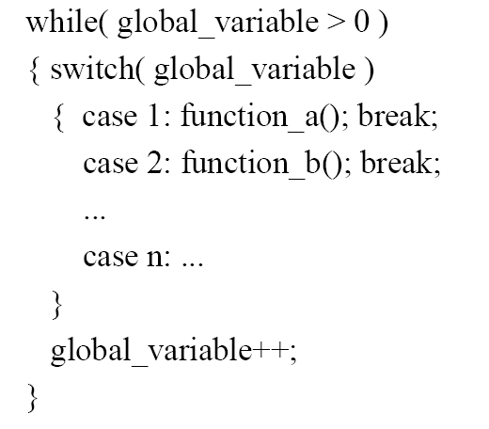

内聚
- Coincidental cohesion：one supporting tasks that have no meaningful relationship to one another
- Logical cohesion：
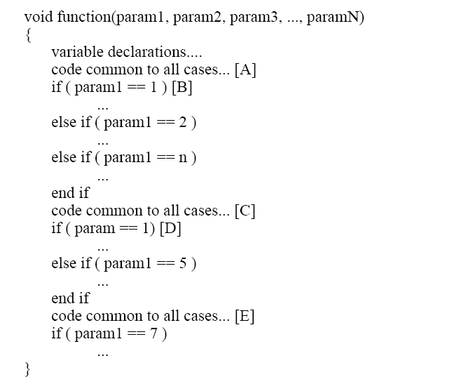
又例如：
- Go by Car Go by Train Go by Boat Go by Plane
- Temporal cohesion：one supporting tasks that are all related in time
例如 “Do All Startup Activities,” or “Do All Shutdown Activities”
- Procedural cohesion：all the operations it performs are related to a sequence of steps performed in the program.
例如：“Prepare for Holiday Meal:”
Clean Utensils from Previous Meal Prepare Turkey for Roasting
Make Phone Call Take Shower Chop Vegetables Set Table
代码重复：
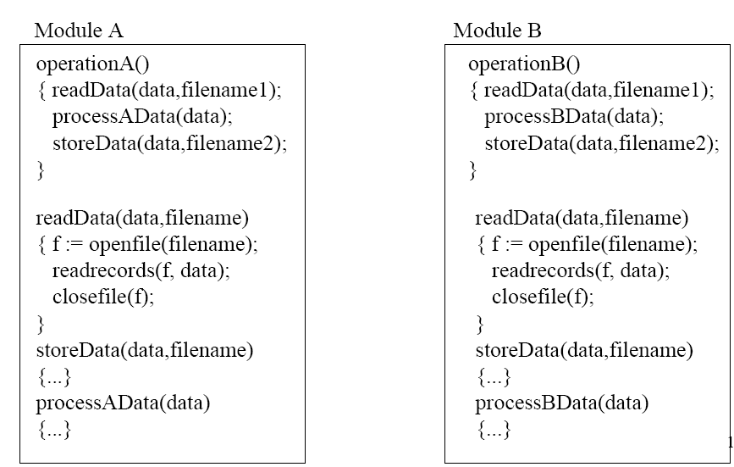
- Communicational cohesion：a module performs operations related to a sequence of steps performed in the program (see procedural cohesion) AND all the actions performed by the module are performed on the same data.
例如
module supporting the activities
Find Title of Book Find Price of Book Find Publisher of Book Find Author of Book
- Sequential cohesion：output of one element is input the next
- Functional cohesion：focuses on exactly one goal or “function”
例如Compute Cosine of Angle
- Informational cohesion：Informational cohesion describes a module as performing a number of actions, each with a unique entry point, independent code for each action, and all operations are performed on the same data. 模块里的每一个方法只能执行一个动作
判断的标准：compound sentence >1 more than one function,so probably sequential or temporal
Time words firt,next.. probably sequential or temporal binding;
Does not have a single object,probably logically bound
Initialize clean up :imply temporal binding;
- 面向对象的耦合类型；
参考笔记
  - Interaction coupling：类之间的方法调用或属性访问，不包括继承，属性和参数不含class type
  - Component coupling: by the use of a class as domain of some instance variable of another class
- Whole variable: Aggregation
- Parameter: Method Parameter
- Creator: Creator in some method’s local
- Hidden: Given by another object

Hidden ：C’不在C的规格说明中也不在C的实现中，但C的一个方法的使用中使用到了C’
Scattered: 在实现中但不在规格说明中
Specific ：在实现中且在规格说明中
  - Inheritance coupling
- Modification inheritance coupling：无规则和限制的修改 2 connections
- Refinement inheritance coupling: 根据规则定义新的 1+connections (whole parent and refinement of child)
- Extension inheritance coupling: 只增加不修改 1connection (whole parent)
Component coupling: 1 whole variable:Aggregation 2 parameter:method parameter; 3 creator creator in some method’s local 4 hidden :given by another object
- 对给出的例子：
- 判断其内聚和耦合的类型，并将其修正为正确的类型。
content coupling
例如Part of program handles lookup for customer.
When customer not found, component adds customer by directly modifying the contents of the data structure containing customer data.
Improvement:
When customer not found, component calls the AddCustomer() method that is responsible for maintaining customer data.
Common coupling
Each source process writes directly to global data store. Each sink process reads directly from global data store.
Improvement :
Data manager component is responsible for data in data store. Processes send data to and request data from data manager.
Stamp coupling
The print routine of the customer billing accepts a customer data structure as an argument, parses it, and prints the name, address, and billing information.
Improvement :
The print routine takes the customer name, address, and billing information as an argument.
Logical cohesion
A component reads inputs from tape, disk, and network. All the code for these functions are in the same component. Operations are related, but the functions are significantly different.
Improvement:
A device component has a read operation that is overridden by sub-class components. The tape sub-class reads from tape. The disk sub-class reads from disk. The network sub-class reads from the network.
Temporal cohesion
A system initialization routine: this routine contains all of the code for initializing all of the parts of the system. Lots of different activities occur, all at init time.
Improvement:
A system initialization routine sends an initialization message to each component.
Each component initializes itself at component instantiation time.
- 分析其Connection类型，计算不同Connection类型的数量。
- 模块间的connection
    - To Common environments General, Scoped
    - To other module
  - 对象的connection
  - 聚合的connection
  - 继承的connection
模块间connection：
- 针对公共环境： 共享变量，共享数据：
1．模块对与其共享数据的其他模块之间的耦合：
一个模块的错误传递给所有关联模块， 理解一个模块需要其他模块，可理解性差； 难以复用
2．在公共环境中每个元素的增加会很大的影响整个系统的复杂度
3．一个良好构造的系统，通过定义好的接口来传递变量比拓展使用公共或者共享变量更加有效和易于维护。共有-》私有
- 针对其他模块：调用方法，变量：
模块间connection计算：
如果M个模块共享N个数据，则有M*N个connections
如果M1个模块共享N1个数据，M2 个模块共享N2个数据，则有N1*M1+N2*M2个connections
(M1+M2=M, N1+N2=N)
封装可以降低耦合。

3信息隐藏
- 对简单的应用，按照“处理流程”与“信息隐藏”两种方式分别给出设计描述。
(考点是什么是信息隐藏)
概念：each module hides the implementation of an important design so that only the constituents of that module know the details ; All design decision are independent of each other;
信息隐藏的原则
  - 每一个模块的是实现都是一个秘密
  - 每一个模块的接口都抽象且精确的描述
  - 从可能改变的实现细节中抽象
  - 把不能隐藏的可变部分参数化
- 对简单的应用，解释其Module Guide
复杂系统需要建立模块化结构层次化的结构文档:module Guide:
内容：功能说明，设计思路：secrets+interface+roles+facilities
作用：Helps developers and maintainers of the system find modules affected by a change
- 帮助开发者和维护者找到被变化影响的模块.Well-structured Module Guide needed to provide development support and to cut down maintenance costs. 结构良好的module guide可以提供开发支持和减少维护开销
- Specifically, for each module the Module Guide states :
  - the secrets associated with each module模块相关的secrets
    - Primary Secret: hidden information that was specified to the software designer. Hidden information contained within the module.准备对外隐藏的内容（需求角度），模块内包含的隐藏信息
    - and a secondary secret, which refers to implementation decisions made by the designer when implementing the module designed to hide the primary secret. Implementation decisions used to implement the module.实现时需要隐藏的内容（设计角度），用于实现模块的决策
  - the roles played by the individual modules in the overall system operation;模块在整个系统中扮演的角色
  - the facilities provided by each module., 每个模块提供的设施
补充：建立模块化结构的目的：
1．每个结构足够简单易于理解
2．每个结构的改变不影响其他且不需知道其他模块的实现所需的知识
3．预计的修改与要改变的设计之间有合理的关系
4．软件的主要改变可以被分解为对每个模块的独立改变
5．软件工程师应该可以只通过接口不通过内部实现设计来理解一个模块的职责
6．有一定关注点的阅读者可以不学习无关模块就很快的识别出相关模块
7．在图上的非终端模块的分指数木必须足够小，这样设计者才能保证子模块间无重合的只能，并且证明模块已经覆盖了所有应该覆盖的职能。
补充：Design through documentation:
- Module Guide: Helps developers and maintainers of the system find modules affected by a change帮助开发者，维护者找到被改变影响的模块
- Module Interface Document : Contains precise and complete description of interface to each module精确完整的描述每个模块的接口
- Module Design Document : An internal design document for each implementation of a module每个模块实现的内部设计文档
- Requirements Document : Module Guide refers to it for the related changes相关变换
4软件体系结构风格
- 描述或比较相关风格
（不考察给代码的情况，以下内容参考去年总结材料）
1以模块为对象的体系结构风格
 | Main-program-and-subroutine | Object-Oriented | Pipe and Filter | Implicit Invocation
Change in algorithm | Bad | Medium | Good | Good
Change in data representation | Bad | Good | Medium | Medium
Chang in functions | Medium | Medium | Good | Medium
Make system interactive | Medium | Medium | Bad | Medium
Space performance | Good | Good | Bad | Good
Time performance | Bad | Bad | Medium | Good
Reuse components | Bad | Medium | Good | Good

- Main Program and Subroutine Style
- 结构：
- Components: 程序，功能，模块
- Connectors: 函数间的调用
- 特点：
  - 控制从顶层开始，逐渐细化至最低层，不允许同级和向上调用
  - 层次化分解：先声明后定义
  - 单线程控制
  - 隐含“子系统结构“，分解结构，子路径属于上个模块的聚合但又无法调用回去
  - 层次化推理：只要子过程正确，即可保证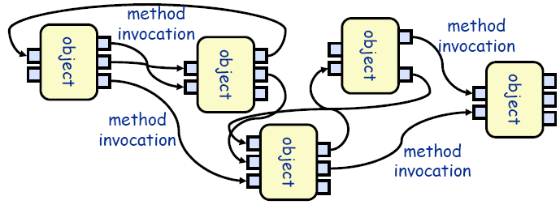整个锅程正确，串行调度，正确性极好
- 优点：
处理清晰，容易理解
可强正确性控制，部分正确即可得整体正确
- 缺点：
不利于修改复用；处理不好会变成公共耦合
- 使用情景：
顺序系统，对系统正确性要求高的系统
- Object-Oriented Style
- 结构：
- Components: 对象或模块
- Connectors: 函数或调用
- 特点：
  - 所有数据信息封装与隐藏
  - 每个对象都是自治的，互不干涉，彼此独立
  - 对象有义务维护自己封装信息的一致性和完整性
  - 所有component平等，可以任意调用，无层次限制
- 优点：
- 因为对象对其它对象隐藏它的表示，所以可以改变一个对象的表示，而不影响其它的对象。只要不改变接口，相互修改性较好。
- 数据表示和相关操作封装为抽象数据类型
- 设计者可将一些数据存取操作的问题分解成一些自治的交互代理程序的集合。
每部分独立，每部分正确性易于确定，方法在对象中被调用，可以将问题分解为交互的代理
- 缺点：
- 为了使一个对象和另一个对象通过过程调用等进行交互，必须知道对象的接口标识，有依赖性。只要一个对象的标识改变了，就必须修改所有其他明确调用它的对象。
- 必须修改所有显式调用它的其它对象，并消除由此带来的一些副作用。例如，如果A使用了对象B，C也使用了对象B，那么，C对B的使用所造成的对A的影响可能是料想不到的。有重入问题。
- 使用情景：核心问题是识别并保护相关信息体的程序
- Pipe and Filter Architectural Style
- 结构：
- Components: Filter,提供数据局部转化，并且使用增量处理，已使得输出数据再所有输入数据完成之前产生
- Connectors: Pipe，作为流传输的通道，把一个Filter的输出传到另一个的输入
- 特点：
  - Filter之间不共享状态和数据
  - Filter不知道它上下游Filter，只知道自己的功能
  - 单个filter不需依赖要知道其他filter才能构建的假设
  - 整个网络的正确性不应该依赖于Filter的排列顺序
  - 完全独立，可以随时增减filter，可以并行开发
- 优点：
- 使得软构件具有良好的隐蔽性和高内聚、低耦合的特点；
- 易于理解，允许设计者将整个系统的输入/输出行为看成是多个过滤器的行为的简单合成；
- 支持软件重用。只要提供适合在两个过滤器之间传送的数据，任何两个过滤器都可被连接起来；
- 系统维护和增强系统性能简单。对顺序无依赖性，新的过滤器可以添加到现有系统中来；旧的可以被改进的过滤器替换掉；
- 允许对一些如吞吐量、死锁等属性的特殊分析；
- 支持并行执行。每个过滤器是作为一个单独的任务完成，因此可与其它任务并行执行。
- 缺点：
- 通常导致进程成为批处理的结构。这是因为虽然过滤器可增量式地处理数据，但它们是独立的，所以设计者必须将每个过滤器看成一个完整的从输入到输出的转换。
- 传输数据需要额外的空间。
- 不适合处理交互的应用。当需要增量地显示改变时，这个问题尤为严重。各部分独立，难以全局控制。
- 因为在数据传输处理的不一致性，每个过滤器都增加了打包，封装和分解数据的工作，这样就导致了系统性能下降，并增加了编写过滤器的复杂性。
- 使用情景：对有序数据进行一系列独立运算处理的程序，如Shell，Compiler
特殊：流水线和批处理
- Implicit invocation (Event based ) Style
- 结构：
- Components: agent代理程序(对象、程序、进程)
- Connectors: broadcast mediums广播媒介(事件处理器)
- 特点：
  - 一个组件可声明事件，另一些组件以函数去注册事件，当事件触发时，广播媒介根据注册分发事件，Connector自动触发注册的函数调用。一个或者多个
  - 事件抛出者不知道谁接受事件，不需假设一定有处理和谁处理
  - 不能假定事件是否被处理以及被处理的顺序
- 优点：
- 为软件重用提供了强大的支持。当需要将一个构件加入现存系统中时，只需将它注册到系统的事件中。
- 为改进系统带来了方便。当用一个构件代替另一个构件时，不会影响到其它构件的接口。
- 缺点：
- 正确性和完整性无法保证
- 难以测试和调试
- 构件放弃了对系统计算的控制。一个构件触发一个事件时，不能确定其它构件是否会响应它。而且即使它知道事件注册了哪些构件的构成，它也不能保证这些过程被调用的顺序。
- 数据交换的问题。有时数据可被一个事件传递，但另一些情况下，基于事件的系统必须依靠一个共享的仓库进行交互。在这些情况下，全局性能和资源管理便成了问题。
- 既然过程的语义必须依赖于被触发事件的上下文约束，关于正确性的推理存在问题。
- 使用情景：一系列松耦合的组件，一些组件在执行操作时，影响另一些组件
松散耦合的系统：调用不能太多；可以分成几个部分相互处理
- Repository (Blackboard) Style
- 结构：
- Components:
代表系统正确状态的中心数据结构
一系列操作中心数据结构的独立组件
监视状态改变并回应的代理
- Connectors: 过程调用或内存读取
- 特点：
  - 除了blackboard，任何两个agent部件独立
  - 新的通讯必须基于blackboard实现，每个部件强依赖于中心blackboard，共享数据
  - 每个agent的行为方式：
    - Blackboard（推模式），如Chat room，被动，结构复杂但客户端易实现
    - Repository (拉模式)，如Web log，主动，结构简单但客户端复杂
- 优点：
- 充分存储利用大量数据的有效方式
- 共享模型被发布到仓库中心
- 减少了数据的复制分片
- 集中管理：备份、安全、并发控制
- 缺点：
- 需要预先对数据模型达成共识
- 黑板成为瓶颈
- 数据演化非常昂贵
- 使用情景：中心问题是建立、增强和维护一个复杂、稳定的信息体，如数据库，黑板专家系统，编程环境
- Layered Style 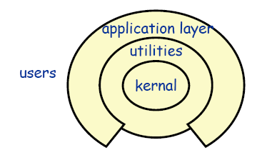
- 结构：
- Components: 一系列过程和对象的集合
- Connectors: 函数或引用，可见
- 特点：
  - 严格的层次结构：底层为上层提供服务，调用下一层，上层作为底层的客户
  - 可以允许跨层，当效率很重要的时候
- 优点：
- 设计：支持基于抽象程度递增的系统设计，使设计者可以把一个复杂系统按递增的步骤进行分解；
- 支持功能增强，因为每一层至多和相邻的上下层交互，因此功能的改变最多影响相邻的上下层；易于修改
- 支持重用。只要提供的服务接口定义不变，同一层的不同实现可以交换使用。这样，就可以定义一组标准的接口，而允许各种不同的实现方法。
- 缺点：
- 并不是每个系统都可以很容易地划分为分层的模式，甚至即使一个系统的逻辑结构是层次化的，出于对系统性能的考虑，系统设计师不得不把一些低级或高级的功能综合起来；
- 很难找到一个合适的、正确的层次抽象方法。
- 使用情景：可以按照抽象程度\功能划分为多个层次，包含一系列可被分层服务的程序，如分层通讯协议，操作系统
- MVC Style
- 结构：
- Components:
Model: 维护领域模型，并通知View相关变化
Controller：改变model状态，并选择返回的视图
View：把信息显示给用户，并把用户的操作发送给Controller
- Connectors: 函数调用，消息，事件，直接内存访问
- 优点：
- 允许同一模型的多个视图存在
- 视图可同步
- 可插式视图和控制器
- 缺点：
- 增加的复杂度
- view中数据访问的低效
- 可能和当前流行的UI工具兼容
- 使用情景：
界面在运行时可以被随时更换，改变或者使用用户接口不影响应用的功能部分的设计和代码。如Web程序

2 以进程为对象的体系结构风格：
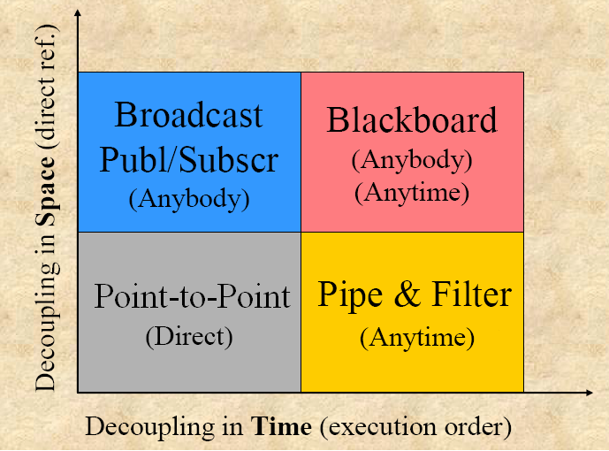
- 点对点point to point
- 分布式系统中的异步消息传递：
松散耦合的体系结构，组件随意
- 机器内或者跨网络：
机器内：共享数据
跨网络：远程过程调用，中间件，基于同步过程调用的CORBA/RMI
- 消息发送给唯一的接受者
- Publish-Subscribe Architecture Style
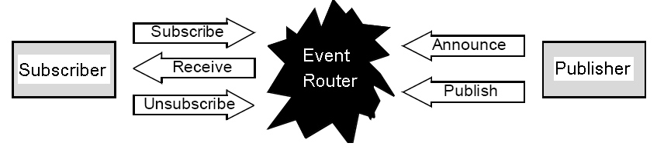
- Components: publisher/subscriber
- Connector: event router
- 特点：
  - 类似事件，进城消息而非模块控制：多进程需接受同样信息
  - 发布者订阅者：松散耦合，时间上必须同时，空间上不一定，信息发送基于时间订阅
  - 灵活参与对象，一对多
  - 发布内容可按照内容进行组织
  - Event router可对消息转换封装处理
  - 消息总线：实现多对多
- 优点：方便利用subscriber的信息
- 缺点：Event router结构复杂，容易失败

3以物理单元为对象的体系结构风格
- Client-Server
- Three-Tier (N-Tier)
- Peer-to-Peer
- Distributed System
  - Distributed Objects (middleware)
  - Distributed Resources (http)
  - Distributed Services (web service)
- 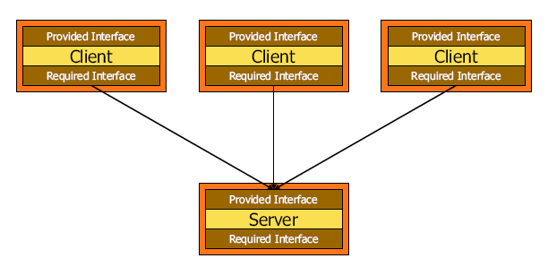Client-Server
- 结构：
- Components: 客户、服务器
- Connectors: 基于RPC的交互协议（远程过程调用或者网络协议）
- 特点：
  - 服务器不知道客户机的身份，客户端必须知道服务器地址
- 优点：client可以随意变更，server不变
- 缺点：server设计困难，成为瓶颈
- 举例：File server, web server, ftp server, e-mail server
- Three-Tier (N-Tier)
- 三个子系统层：
  - 接口层 (或者前端)：和用户交互的子系统，包括接口，网页，表单etc.
  - 应用逻辑层 : 包括处理单元
  - 存储层 ( 或者后端): 处理持久层数据的查询和存取
- 相当于在C/S结构中加入了一个中间层，提供了用户界面和控制逻辑的分离
- 优点：性能高，修改好
- Peer-to-Peer
- 结构：
- Components:自治区，可以扮演客户端和服务器的角色
- Connectors: 同步和异步消息（远程过程调用），没有共享内存（除非配置允许优化）
- 特点：
  - 网络拓扑结构可以是任意，动态的
  - C/s结构的一种推广：每个子系统可以扮演客户端和服务器的角色
  - 相对难以实现：控制流较复杂，每个控制流都必须被同步
- 举例：eMule, eDonkey, Gnutella, Freenet, On Share, etc. are examples of a P2P systems
- Distributed System：
- 分布式对象（Middleware）、分布式资源（http）、分布式服务（SOA）
Middleware-Oriented Distributed System Architecture Style
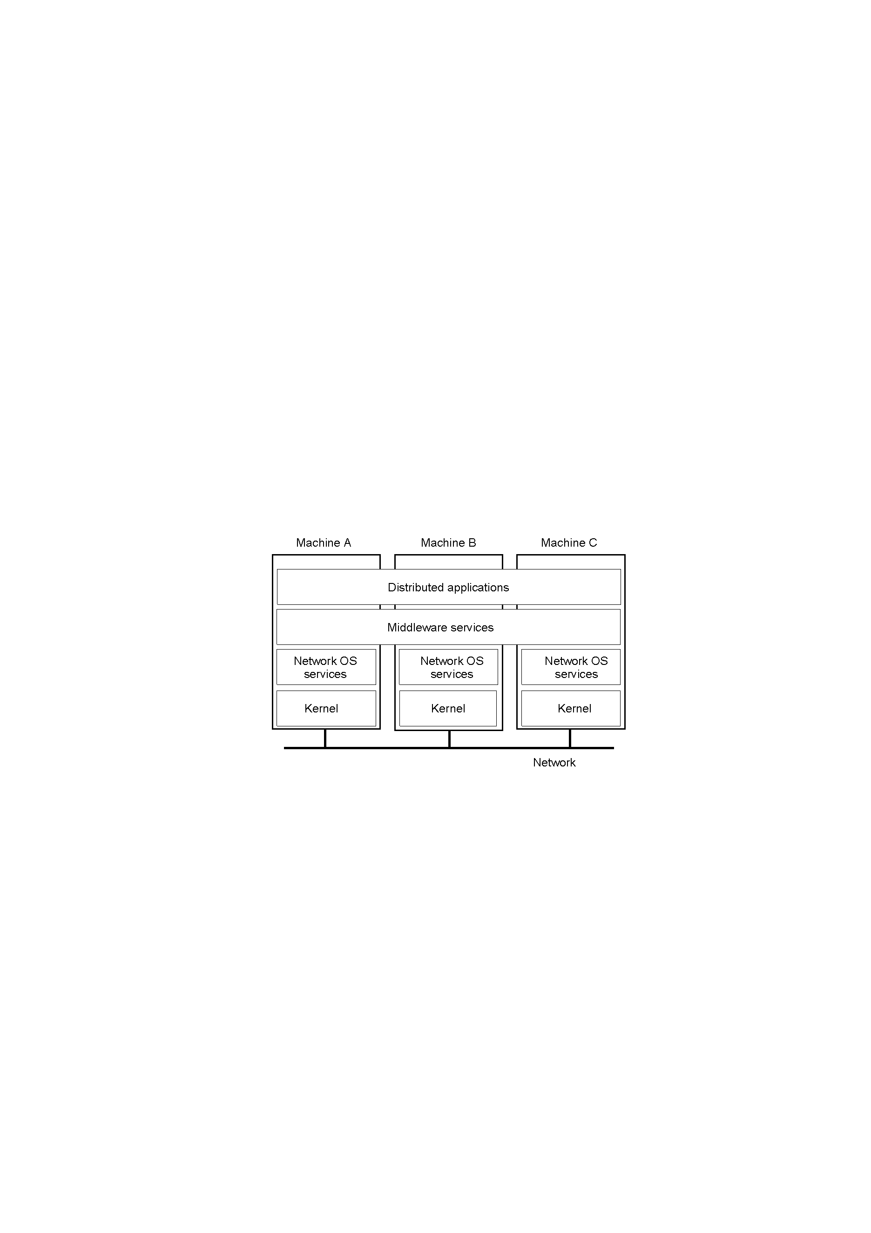
        - 根据分析类图，建立基本的设计类图

6有几种控制流处理方式？进行比较 集中式 委派式 分散式
A control style is a way that decision making is distributed among program components.
  - Centralized—A few controller make all significant decisions
  - Delegated—Decision making is distributed through the program with a few controllers making the main decisions
  - Dispersed—Decision making is spread widely through the program with few or no components making decisions on their own
集中式：
- 特点：
  - 容易发现决策的位置，如何做决策和改变决策过程，
  - controller可能会膨胀：大，复杂，难以理解维护和测试，
  - controller可能把其他部件作为data repositories：增加耦合性，破坏了信息隐藏
- 优点：
  - 防止交互设计，因为所有信息来源于同一个部件；
  - 保持较小的部件
  - 保证功能的职责不分配在极少数的部件中
  - 保证功能的职责与数据职责一致
  - 保证决策的重要性：如果完成后部修改其正确性最高
代理式
- 特点：
  - Controller只与少量部件相关，减少耦合程度
  - Component 简单可控，信息更好的隐藏
  - 程序更容易被分层
  - 代理控制是比较好的控制风格
- 改进：部件应代理越多的底层任务越好
分散式：
- 特点：
  - 很多组件，每个只有极少的数据和职责
  - 难以理解控制流
  - 组件自己无法做很多工作，增加了耦合
  - 难以信息隐藏
  - 内聚很低
  - 不满足大多的模块化原则
- 改进：应尽可能防止需要组件发送很多消息的交互

- GRASP模式
- 对外部事件交互，应该如何处理？

- 对给定场景，判断职责的分配

- 设计模式
- 普通Programming to Interfaces有哪些手段？
Collection 和inheritance
指向模块整体用户名称的链接和寻址的链接比指向其他模块内部元素的链接的耦合低。

- 集合类型Programming to Interfaces有哪些手段？
设计模式：
Iterator pattern 为不同的聚合结构提供统一的接口，支持多态迭代。
- 提供访问一组集合而不需要曝光其内部的表示方法：
- 支持集成对象的多种遍历
- 提供统一的遍历接口，给不同的集成结构
- 结果：
  - 1。面向接口的变成和信息隐藏
  - 2。支持一种集合的多种遍历形式。只需要替换不同的iterator实例
  - 3。Iterator简化了集合类型的接口。Iterator的遍历接口违背了在集合中相似接口的原则。
  - 4。一个集合上可以挂不止一个的遍历
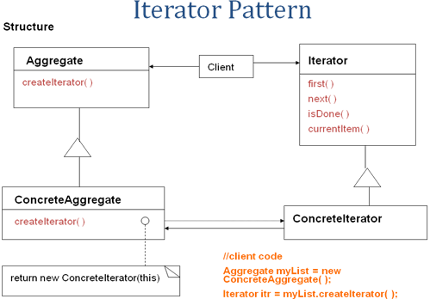

Proxy pattern ：client 只和subject定义的接口交互
  - 问题：提供代理以供其他对真正object的访问。
  - 分类：远程，虚拟，保护。
    - 远程：提供给不同的地址空间的地址的对象的本地代理。
    - 虚拟：根据需求创建开销对象。
    - 保护：控制访问原始对象，在访问权限不同时有用。
  - 说明：
    - Subject, realsubject and proxy
    - 用户通常在subject中定义的抽象方法进行操作。
    - 对subject的实现在realsubject和proxy中。
    - 如果接受到有危险的调用，exception 或者alarm提醒
    - Proxy代理了对于realsubject的安全调用。Client通常使用proxy.
  - 结果：
    - Proxy模式引入了对于对象的一个间接的访问方式。
      - 远程proxy隐藏了远程的实现事实或object不在同一地址空间
      - 虚拟proxy可以进行优化，实际对象仍存在
      - 保护proxy额外的安全。
      - 简单，控制，安全，允许写但是需要迭代器实现。
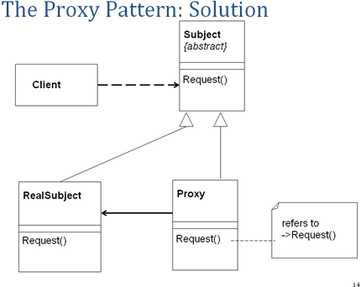

Prototype pattern：原型类声明一个用来克隆自己的接口
传递拷贝，用原型实例表示要创建的对象类型，通过拷贝为原型创建新的对象。
- 思想:请求后得到拷贝，新的object，每个请求得到拷贝的不同版本。
- 参与者：
  - Prototype原型：生命了拷贝自己的接口
  - concretePrototype具体原型：clone自己的实现操作
  - client客户：对原型请求的对象，通过请求原型对象克隆自己来创建新对象
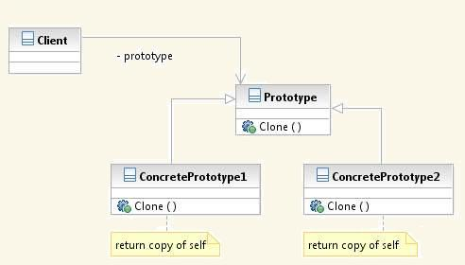

总结：针对接口编程，而不是实现：
- 继承允许定义一组有相同接口的对象
- 所有引申类都与基础类有共享的接口
- 所有子类回应在其抽象父类接口中的请求。
- LSP：所有类都必须可以被其父类替换，子类可以替代父类存在。

- De-Coupling有哪些手段？
- Avoid repetition: do it once防止避免重复
重复意味着耦合，因为对重复代码的一块进行改变意味着要改变其他的
- DIP抽象依赖倒置，依赖接口而不是依赖实现
1)抽象不能依赖细节，细节应该依赖抽象
2)高层模块不应该依赖于底层模块，二者都应依赖于抽象
3)在一个分离模块即将实现的模块中定义接口，基本的方式来打破依赖和降低耦合
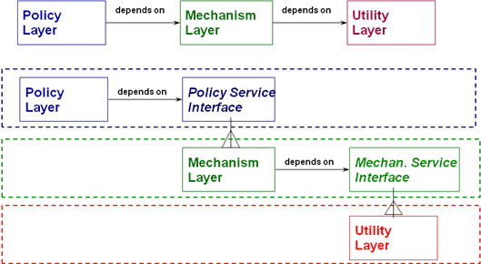
- 继承：公共和变量
- 设计模式：

Mediator pattern 调停者模式：
通过避免对象互相显式的指向对方从而降低耦合
- 问题：
  - 多个对象重复访问，无规律性。
  - 一个对象集合的交互良好定义，但是交互方式复杂。通常有非结构依赖。
  - 对象复用困难，因为对象指向和交互很多其他的对象
  - 在多个类之间的分布式行为的控制问题：应该不用建立很多子类就是先本地化
- 参与者说明：
  - Mediator: 定义了与colleague对象交互的接口，通常被告知事件或者状态
  - concreteMediator：实现与colleague交互的具体行为，了解和维护colleagues
  - colleague： 每个colleague知道自己的Mediator对象，每个colleague当其需要与其他colleague交互时需要先与自己的mediator进行交互，为mediator提供了服务，colleague可能请求相同也可能不同
- 结果：
  - 定义对象，其封装了一组对象的交互方式
  - Mediator促进低耦合，通过纺织对象显示的引用彼此；
  - 让人独立的拓展其交互
  - 集中式控制
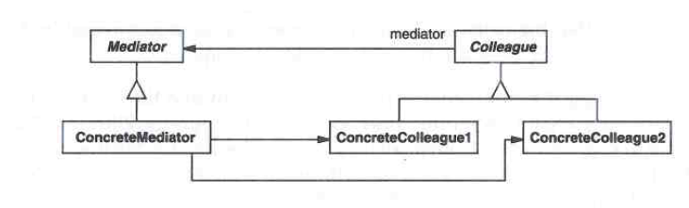

Bridge pattern 桥接模式：
把接口和实现解耦decouples interface and implementation
- 问题：
  - 常用的处理一个抽象有多种实现的方式是继承
  - 然而这会使实现与抽象进行绑定
  - 并不能够灵活，可能需要独立的修改实现或者抽象
- 解决：用聚合代替继承：分离抽象类的继承与实现类的继承，分离抽象和实现，利用代理作为二者的桥接，实现多对多的差异性
- 参与者：
    - Abstraction：定义了抽象的接口
    - RefinedAbstraction：拓展由abstraction定义的接口
    - Implementor: 定义实现类的接口；可与abstraction的接口不同，通常提供了原始操作，abstration提供更加高级的基于该原始操作的操作。
    - ConcreteImplementor:实现implementor的借款购定义的具体实现
- 结果：
  - 实现和接口之间解耦合，抽象与实现独立开
  - 避免了类型检查，降低了变异的时间，减少了编译时的依赖性
  - 提高了系统的可扩展性
  - 将实现细节隐藏，用户不可见
  - 内聚又是可以实现差异性，接口实现都可以修改，抽象和实现分离
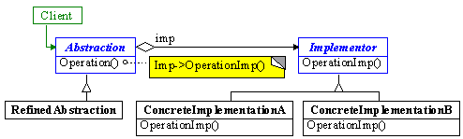

- 一个模块的信息隐藏有哪两种基本类型？
  - 每个模块有一个基本的secret: 外部的行为和内部隐藏
          - 每个模块隐藏重要的设计决策的实现，只有模块的组成可以了解细节
          - 所有的设计决策都独立于彼此
方法：门面模式Facade pattern
  - OCP：模块可能有附加的secrets: change
- 预期的变更： 通过分配给多里的类，历程，或其他设计单元将设计的secret独立出去
- 然后封装隔离所有的secret这样其一旦变更，变更不会影响其他程序模块。
- OCP: Open/ closed principle 开关原则？软件实体应该对扩展开放，对修改关闭。change发生时易于拓展，变成一颗继承树，修改需增加子类，拓展非修改，模块必须是拓展而不需要修改。
方法：策略模式Strategy pattern
装饰模式Decorator pattern
适配器模式 Adaptor pattern
  - Basic secret:
Façade pattern
- 问题：
  - 外部与内部不一致时，隐藏内部，在模块或者子系统处建立一个统一的接口，façade类
  - 定义高层的接口使模块和子系统更加以用：隐藏内部实现细节
- 结果：
  - 信息隐藏：用户和部件的子系统之间解耦合，降低耦合
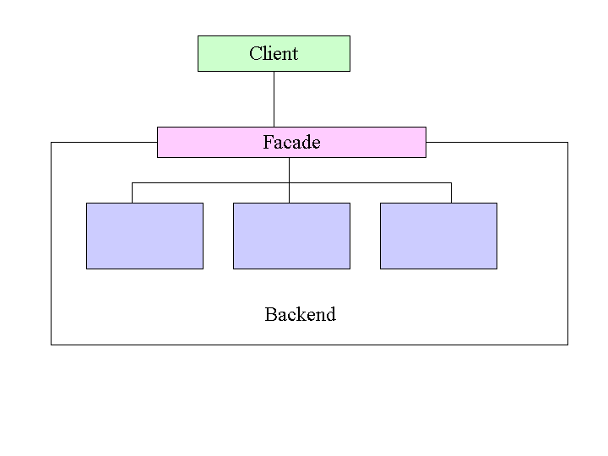

  - Anticipate changes:
Strategy pattern
- 思想：
将算法从对象中分离，封装为一个对象“strategy”
- 问题:
  - 对象包含了解决一个问题的多种选择算法
- 解决：
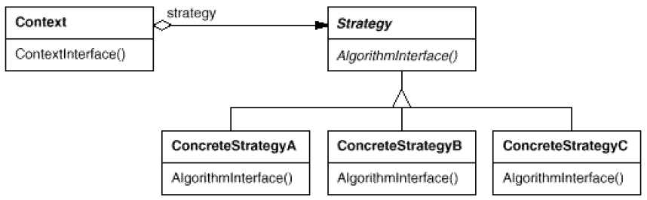
如果上下文也有可变性：用桥接模式bridge：

  - OCP: Be open for extension ，Be closed for modification
Decorator pattern
- 问题：
  - Decorator在不修改类代码的情况下拓展类的实例的功能
  - 用聚合代替继承，比静态的继承更加灵活
  - 在幕后工作，对接口透明
- 解决：
  - 在运行时动态给对象以额外的职责，如果使用继承，则所有的继承那个对象的类有同样的继承职责，不能实现一个对象采用该职责而该类的另一对象不含有该职责的现象
  - 关键是对其装饰的组件来说，decorator是透明的，这样可以嵌套定义decorator，允许无限数量的新增职能
- 结果
  - 比继承更加灵活
  - 防止继承树堆积过高而过于复杂
  - 有很多类很相似，理解上比较困难，难以理解和调试
  - Decorator及其组件并不相同，检查对象相似性和相同性可能引起问题
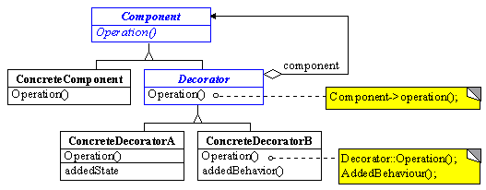

Adapter pattern
- 思想：
  - 新增加功能使用已有接口时，接口不匹配，adaptor类之间的接口协调
  - 将类的接口转化为用户期待的接口
  - 让类共同工作，不受到不兼容接口的影响
- 解决：
- 结果：
  - 灵活性：框架可被开发用来与不兼容的类协调
  - 重用性：现有类实现的有用功能可以被重用
  - 健壮性：现有类被重用但是不需要修改，防止引入不必要的潜在bug

- 实现共性与可变性有哪些手段？
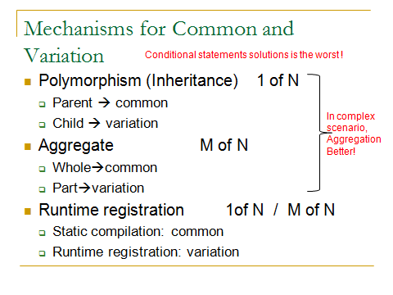
1多态
父：共性
子：差异性

2聚合
整体：共性
部分：差异性
Strategy pattern 聚合

Strategy pattern:
- 问题：
  - 许多相关的类只是在其行为表现上不同，strategy提供一种给类配置多种行为的一种方式
  - 一个雷定义许多行为，这些在其操作中作为多种状态条件存在
  - 需要算法差异性时
  - 一个算法可能使用到客户不知道的数据时
- 结果：
  - 可变性与重用性：
    - 一组相关的算法扩展
    - 子类的替代：context类分配为子类，直接给其其差异性行为
  - 复杂性，难于理解
    - 好：strategy减少了条件判断语句
    - 坏：逻辑分离，用户必须意识到是不同的strategy才可以
- 使用：
  - 如果复杂和多种算法
  - 如果在某些固定特点中有变更的行为
  - 如果有复杂的条件判定语句

State pattern：允许一个对象在其内部状态改变时改变它的行为，对象看起来似乎可以修改它的类
- 问题：
  - 对象的行为依赖于其状态：运行时的变更行为依赖于状态
  - 操作有很多较大部分的选择结构，对于不同的state有不同的选择：每个选择作为一个单独的类
- 解决：collaboration
  - Context代理对于现在concreteState对象的具体状态请求，context决定具体状态饼请求concretestateDUIXIANG
  - 状态决定concreteState类，把自己作为参数传递给concreteState
  - Context只提供interface，物具体内容，用户不直接与state关联
  - 切换状态：context或者concretecontext对象可以决定concreteState对象的变化
- 结果：
  - 根据状态表现异常性，状态转换，本地状态决定特定行为：
    - 容易增加新的状态：新的concrete具体子类
    - 增加了类结构的规模
  - 可以共享数据区：如果无实例变量
  - 使状态转换显示化：减少了潜在的不一致的内在状态
举例：public interface IState{
Public void switchFire(FireSwitch sw);
}
//offstate
Public class OffState implements IState{
Public void switchFire(FireSwitch sw){
sw.setState(new SmallState());
}
}
//swallstate
…
3运行时注册和callbacks
静态编译：共性
运行时注册：差异性
Callbacks:用户方法，注册在服务器，服务器可以撤销。用于拓展的方式。在服务器的对象上操作。
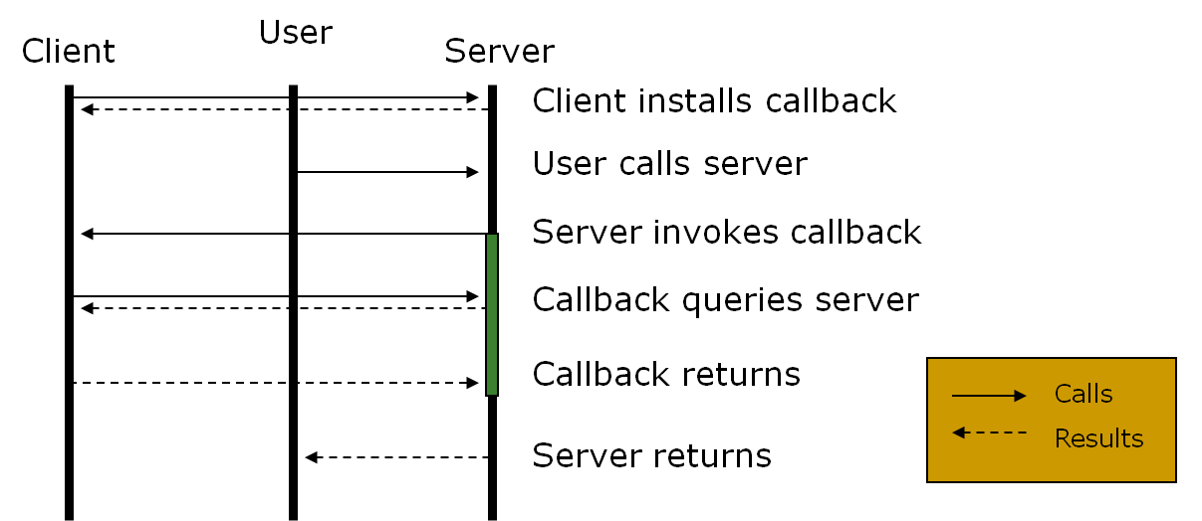
Observer pattern: 定义1对多的对象之间的依赖关系，当一个对象改变状态，所有它的依赖者被通知并且自动更新
- 问题：
  - 定义了对象间的一对多的依赖，这样一个对象改变状态，其依赖被通知并自动更新
- 解决：
- 结果：
  - 灵活性，可变性和重用性：“event”事件风格，低耦合
  - 更加复杂：难于理解和测试
- 使用：调用对方时又差异性问题，不知对方状态
  - 当一个对象改变需要改变其他，但不知道要改变的是哪个对象
  - 当对象应该通知其他其他对象，但不假设其知道哪些对象。不希望这些对象紧密耦合
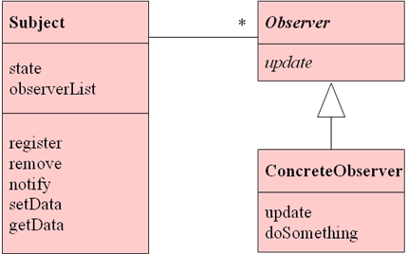

Command pattern
- 问题：
  - 专门对对象进行注册，action处理后交给别人管理
  - 通过对象的行为来参数化对象
  - 可以在任何时刻制定，queue队列和执行请求
  - 通过存储context上下文来支持undo
  - 为了回复系统而支持变更日志
- 解决：
- 结果：
  - 解耦合了请求的receiver和executor
  - 可以在栈或者队列中存储command命令：命令处理器模式维护历史记录
  - 容易支持undo redo：必须提供多余的状态信息来防止hysteresis
  - 易于拓展指令
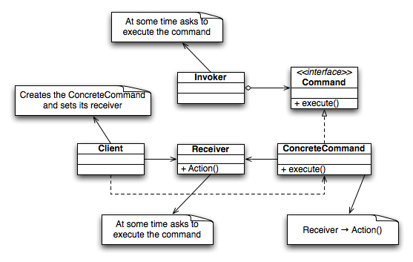

- 对象的创建有哪些常见解决方法？
    - 简单: 无限制的实例，创建一个类型，简单实例化和初始化
Creator pattern Coupling pattern Cohesion pattern
    - 复杂：
场景1：只有一个实例允许被创建
Singleton pattern
- 问题：又是需要一个特定类只有一个实例
- 解决：
  - Constructor private：无法从外部调用
  - 生命类的实例的私有静态单个实例
  - 写公共的getInstance方法或者相似方法，允许对单个实例进行访问
    - 保护或者综合方法来保证其在多线程程序上可以运行
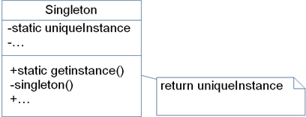
例如
public class Singleton {
private static Singleton instance = null;
private Singleton() {
// ....
}
public static Singleton getInstance() {
if (instance == null) {
instance = new Singleton();
}
return instance;
}
// .. 其它实作
}
场景2： 有限的实例允许被创建 (思考题中有)(工厂 来得现)
场景3： 多种类型，创建类型的差异性（描象工厂）
Factory
工厂：一个负责创建不同类型类的类
封装对象创建
Simple Factory
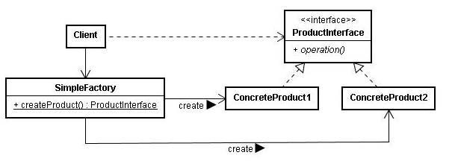
Simple factory实例：
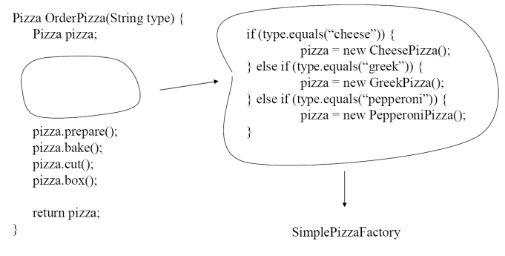
把创建不同pizza的If-else封装到一个工厂类里
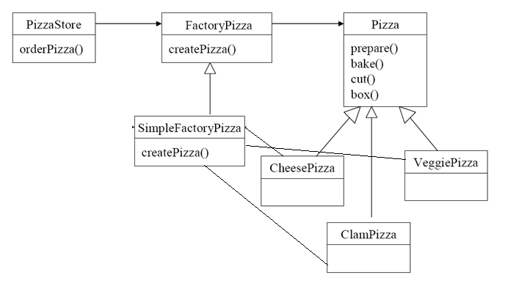

Factory method:定义一个创建对象的接口，但是让它的子类决定实例化哪个类
目的：定义创建对象的接口，让子类决定实例化的类 让一个类延迟子类的初始化 Factory method!=simple factory
结构：参与者
Product: 定义factory method创建的接口
Concreteproduct：实现了product定义的接口
Creator:声明了factory method，返回product类型的对象；也可能定义了factory mentod的缺省实现，返回缺省的concreteproduct类
ConcreteCreator：重写factory mehtod，返回一个concreteproduct的实例
结果：可变性，重用性 具体动态类型与用户代码隔离 为子类提供了hooks：factory method为子类提供了类的拓展版本 连接平行的类的继承关系：用户用factory method创建平行的类的继承
复杂性：Client需要产生creator的子类来创建特定类型的concreteProduct对象
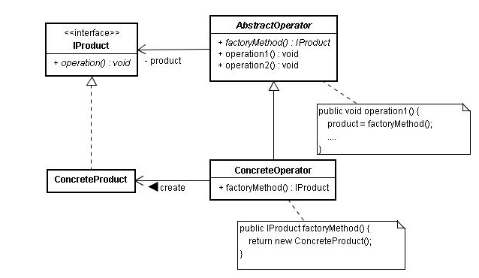
Factory method的例子：
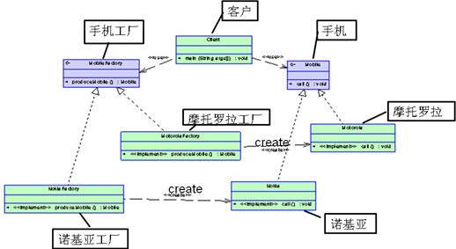

Abstract factory: 指一个工厂等级结构可以创建出分属于不同产品等级结构的一个产品族中的所有对象
目的：为创建一组相关或者依赖的类型提供接口，但无需知道其具体类型
解决：
abstractFactory：声明了一个实例，该实例的主要操作是产生abstractproduct
ConcreteFactory：实现了创建concreteproduct对象的操作：通常singleton初始化，唯一性
Abatractproduct：声明了一个product对象的类型的接口，concretefactory产生concreteproducts
Concreteproduct：定义了要由对应的concrete factory来创建product对象
结果：
Good:独立隔离出具体类：所有在客户段的操作都通过abstract接口实现
使交换产品家族容易：只要改变concretefacotry
加强了products之间的一致性
bad：很难支持新类型的产品 需要重写abstractfactory和其子类 在动态类型语言中不是那么坏
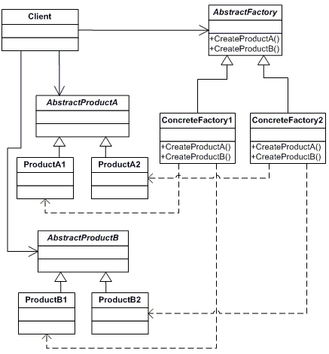
Abstract factory例子
有两个产品等级结构Button和Text，两个产品族：windows产品族和unix产品族
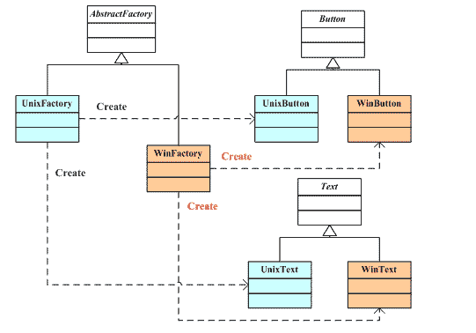

场景4：复杂的初始化和实例化（例如运行时实例化和初始化时值变更）
Prototype pattern
问题：
通过使用原型的实例来指定创建的对象类型，通过拷贝原型来创建新的对象
结果：可以在运行时增减原型 通过多种值指定了新的对象：通过增加新的原型通常定义新的类型以使程序可以初始化 伪动态负载

